**Zocus Rig Instructions**

The Zocus App is free to download. The Zocus ‘Rig’ - comprising of 3D Printed Parts (Open Source) and Electronic Hardware (available on Amazon/ebay/etc.) can be assembled with basic tools (Soldering Iron, Wire Snips, Screwdrivers).

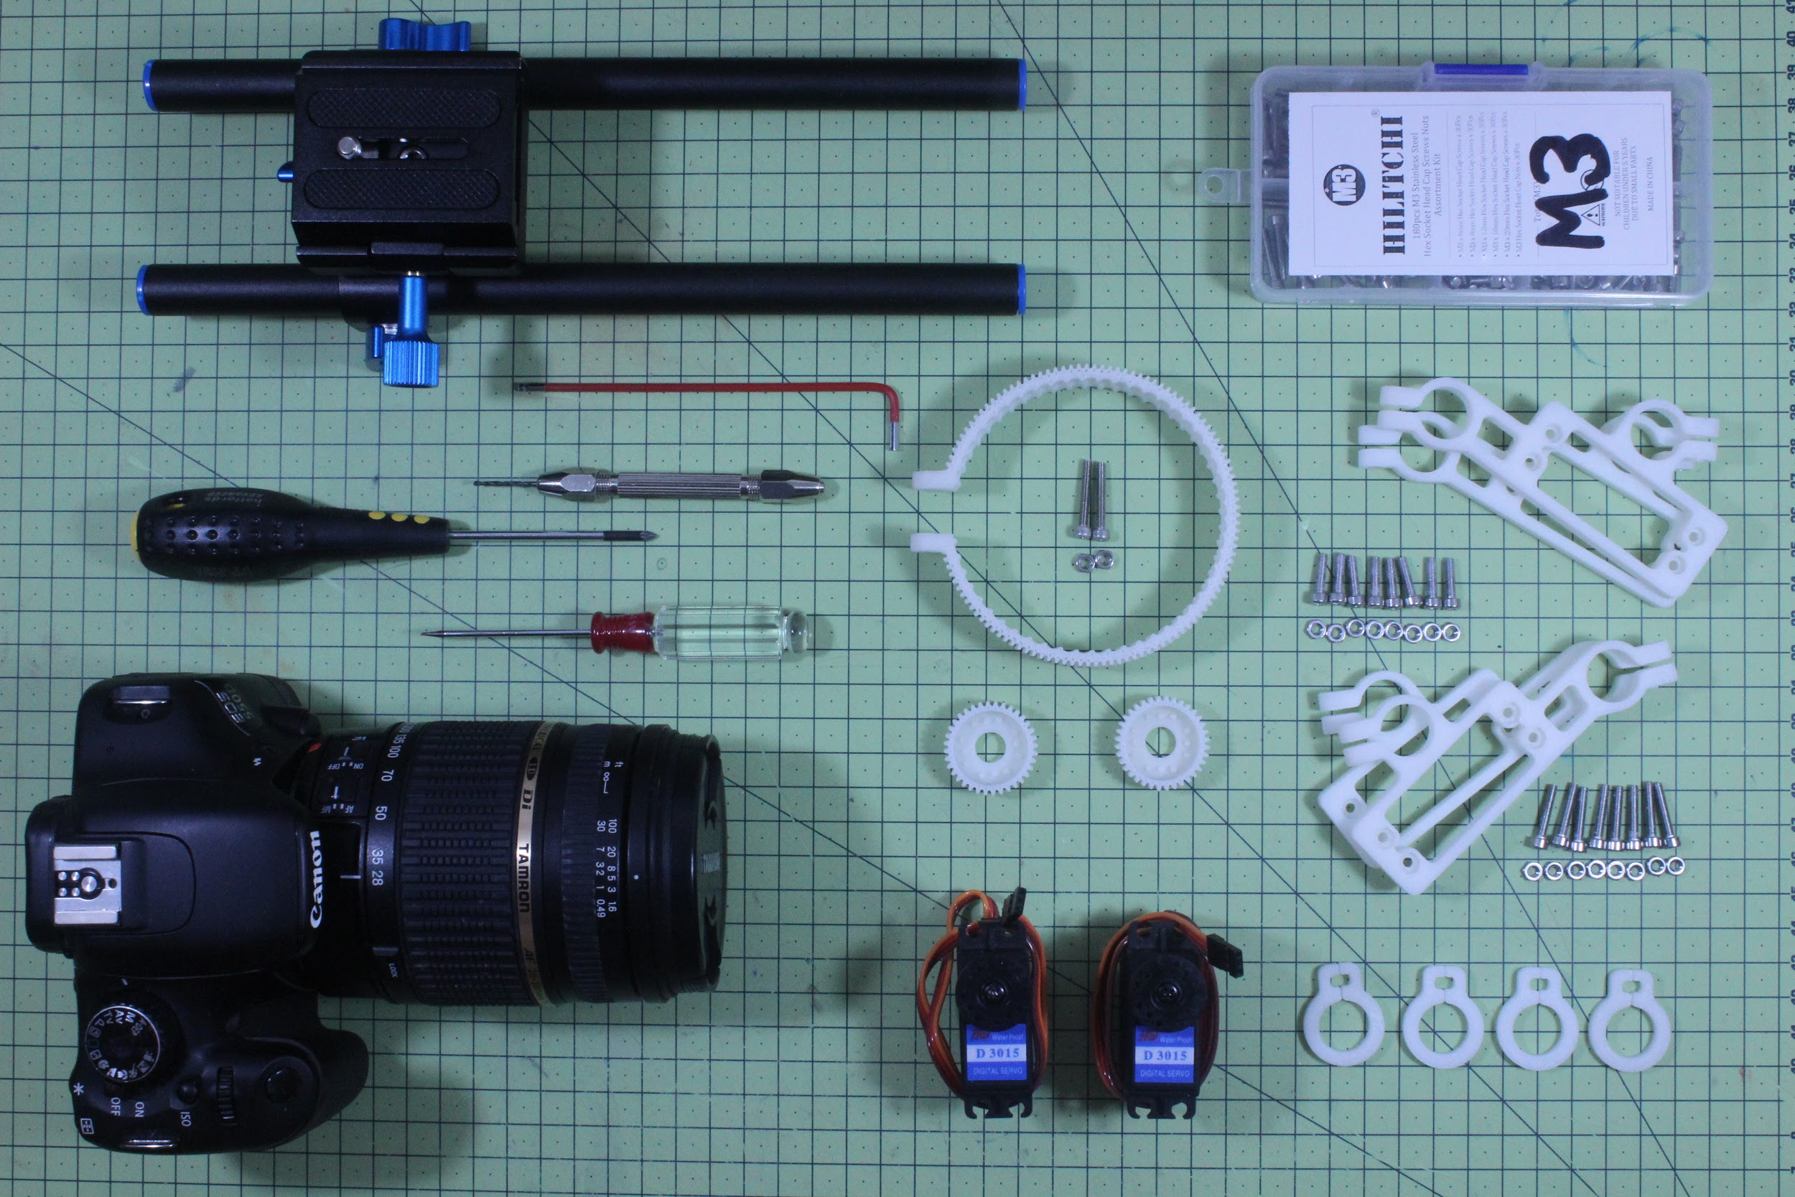

Detailed instructions and CAD files can be found via Instructables.

In general, the process involves attaching rings around the Lens, around the Focus and Zoom Rings. These are then rotated via Servo Motors, underneath, attached to universal 15mm rails (used in all sorts of film and photography equipment). The Servo Motors are controlled via a Blend Micro - which is a Bluetooth enabled control device.

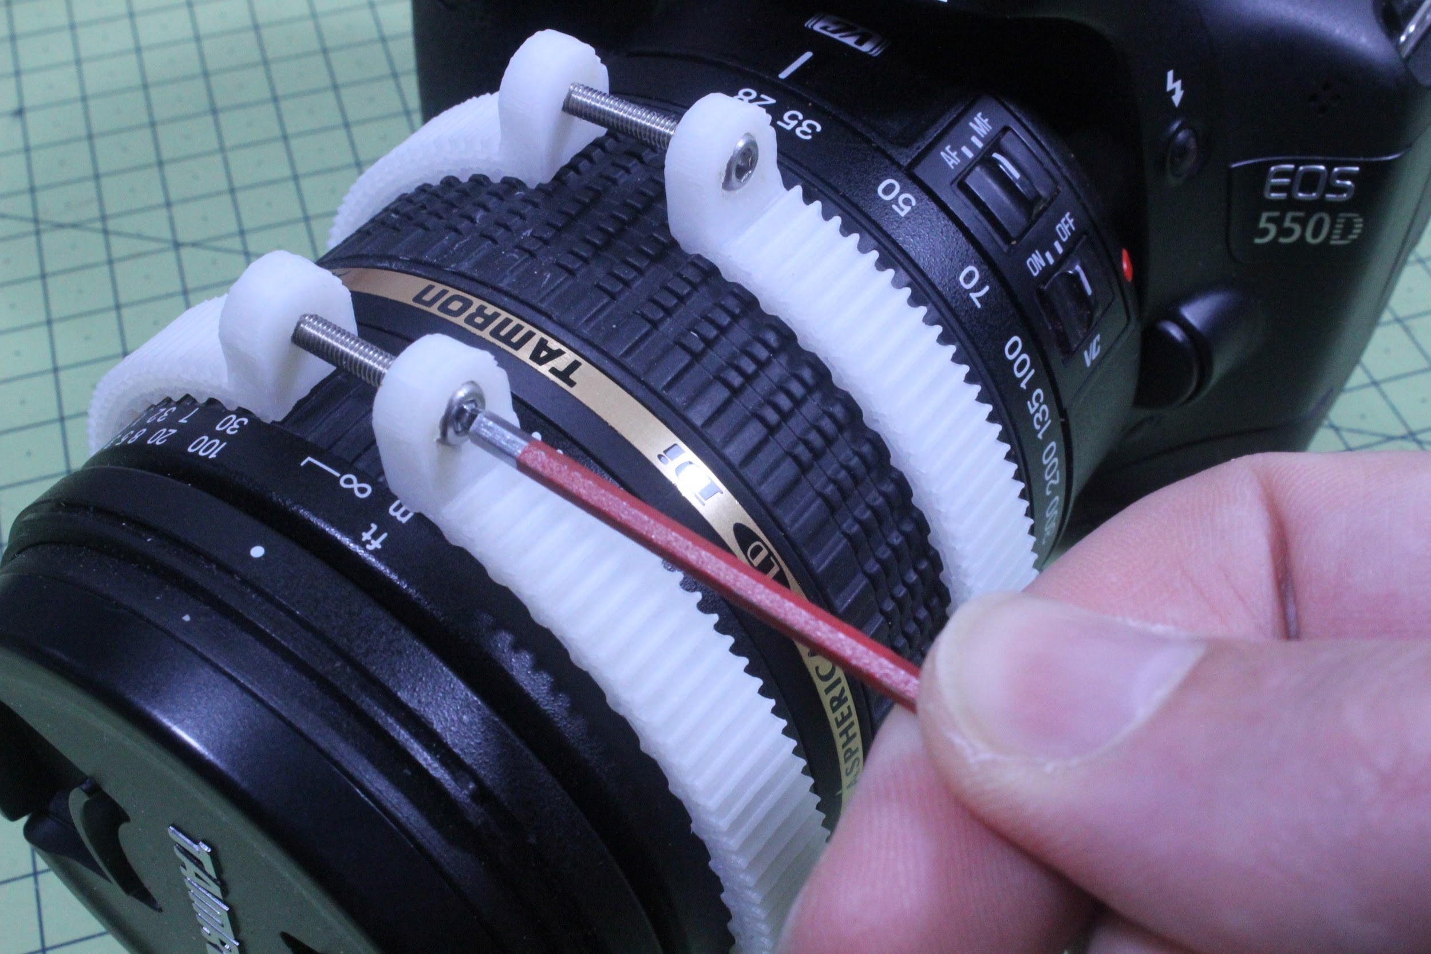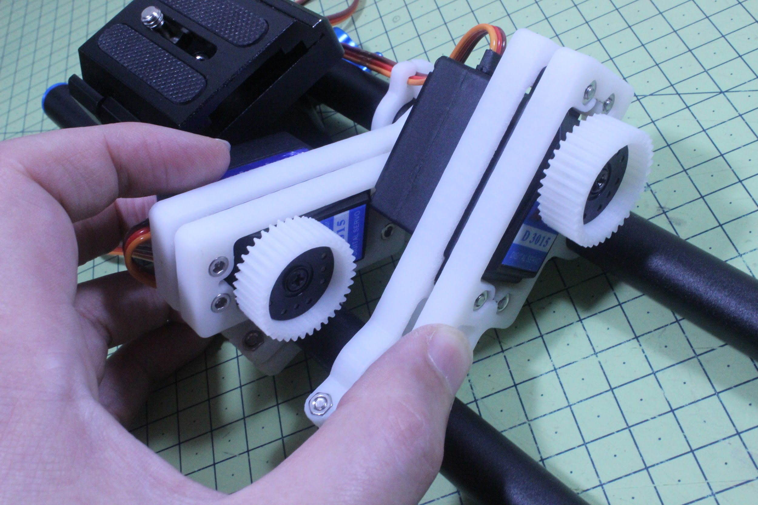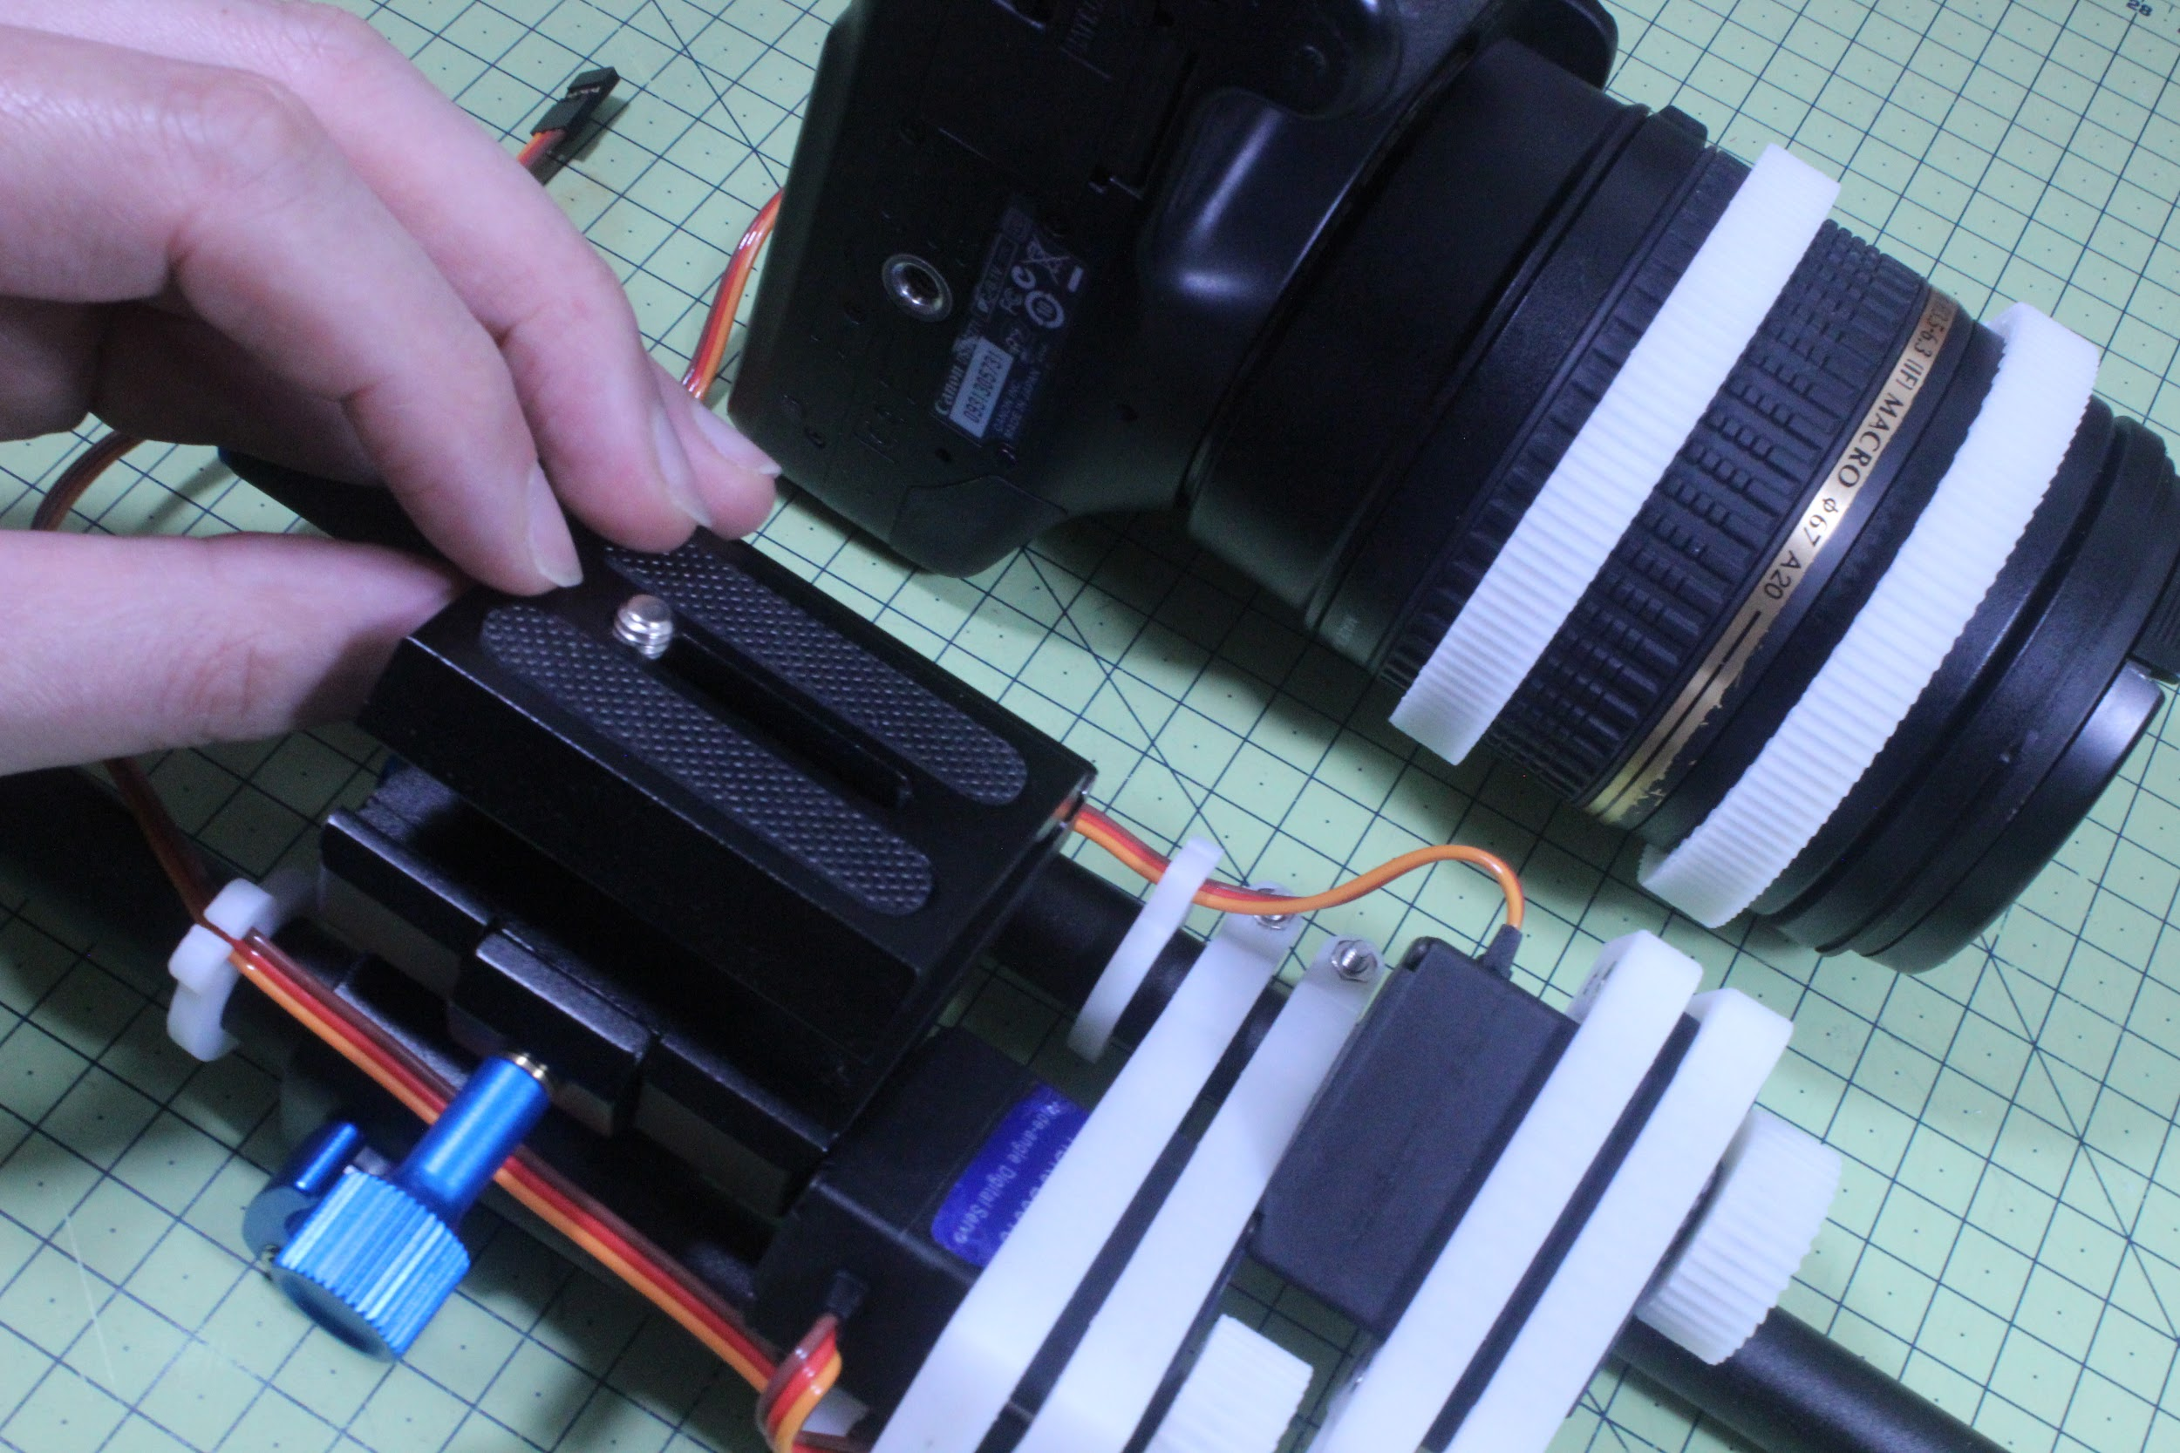

Altogether, the Electronics cost less than £90, which means if you have access to a basic soldering and electronics equipment - and 3D Printer (local maker spaces or hobby clubs often have them) it is quite affordable to build for yourself or someone who needs one!



If you do not have a 3D Printer, then you may find that a local Hackspace or Makerspace will be happy to help you. They are usually voluntary-run organisation, so one might expect that you might get the prints at low cost or free, if you are willing to join as a member and pitch-in to help out with other people’s projects.

However, if you simply want a professional service, you can use any number of online services, such as Shapeways.com. This is likely to range between £50-£150 depending on where you go and what turn-around speed you require. (More on this in on Instructables).



As mentioned, the project is Open Source, so please also upload any improvements or variations for others to try. The recommended platform is either Instructables or GitHub.